**Department of Political Science**

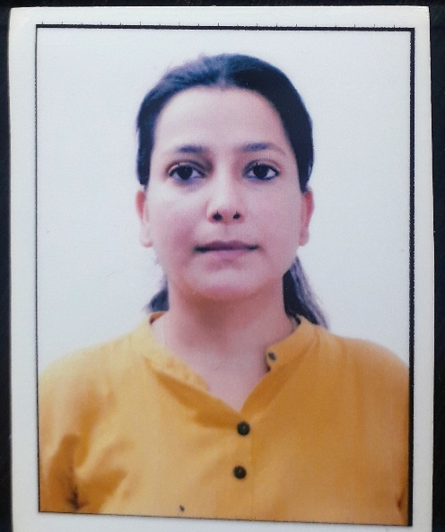

**Name : Jasneet Kour**

**Designation: Assistant Professor**

**Qualification: M.Phil. in Political Science**

**Email id : Jasneet.kour** [**23@gmail.com**](mailto:23@gmail.com)

**Area of Specialization: Indian Political System**