Department: English

Name: Dr Rajiv Katoch

Designation: Associate Professor 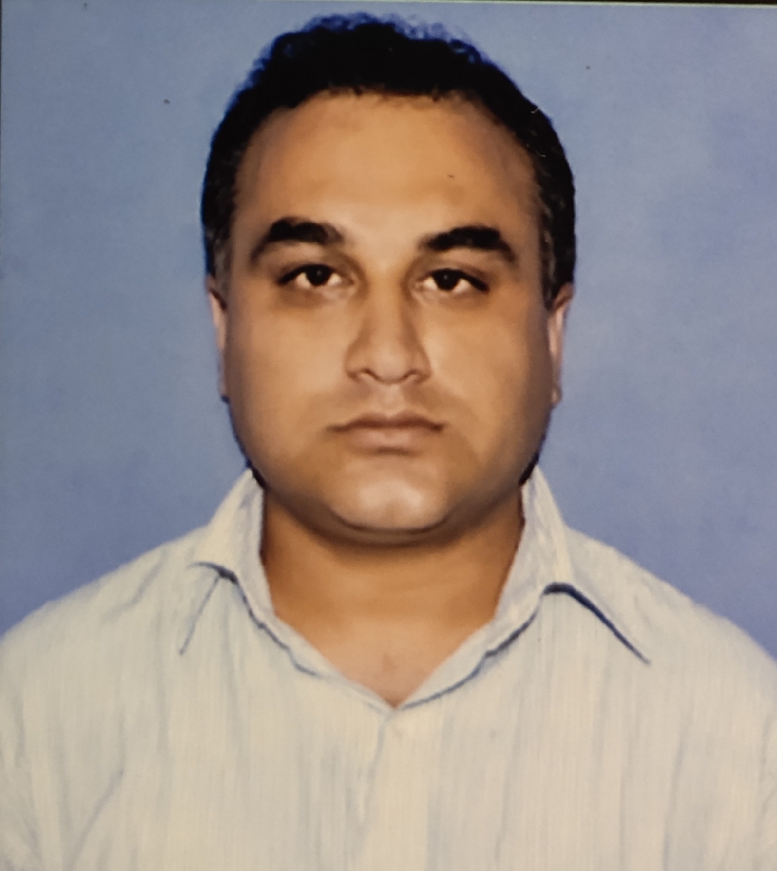

Qualification: M.Phil, Ph.D, B.Ed

Email ID: rajivkatoch75@gmail.com

Area of specialization: Non Fiction

Publications: Four

Any other Achievement: Nil.