**Department of Urdu**

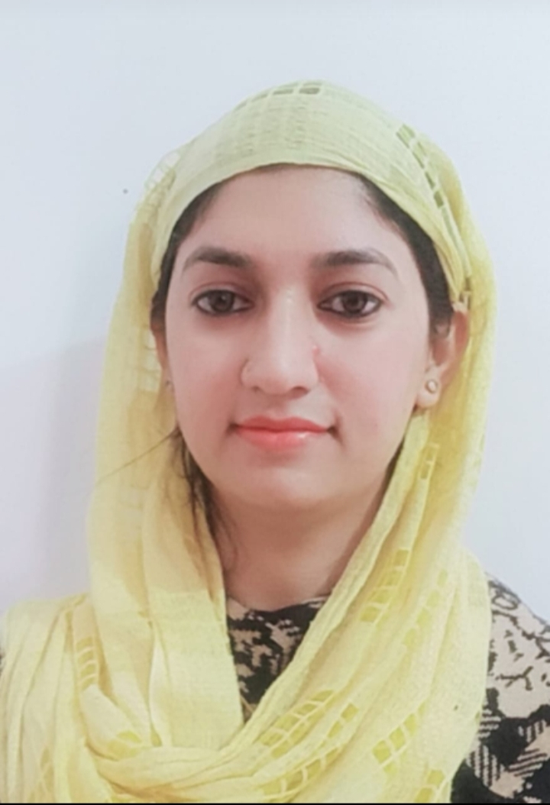

**Name : Dr. Saiqa Naihd**

**Designation: Lecturer**

**Qualification:M.A,Net, Set, M. phil, ph.d in urdu**

**Email id : angelmughal91@gmail.com**

**Area of Specialization: Fiction and criticism**

**Publications_10**

**Any other achievements- Nil**