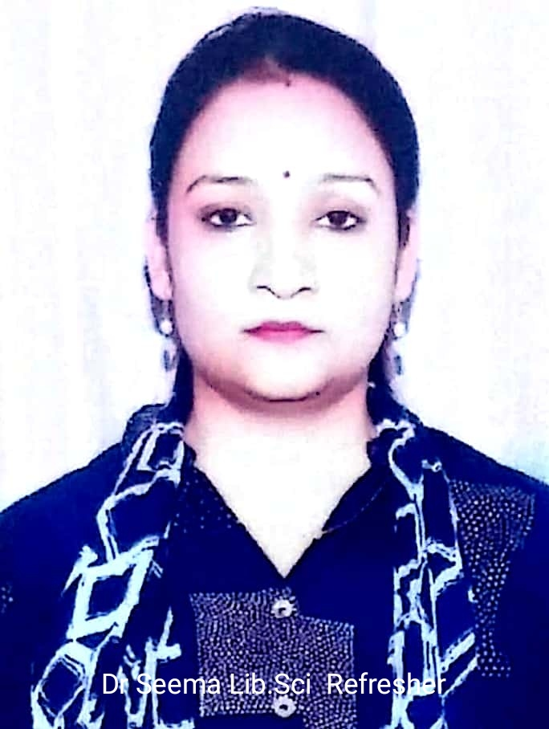

Nane: Dr. Seema

Designation: Librarian

Qualification:PhD, NET-JRF

Email ID: [seemauoj@gmail.com](mailto:seemauoj@gmail.com)

[drseema.78611@jk.gov.in](mailto:Drseema78611@gov.in)

Area of Specialization: Library and Information Science

No. of Publications: 20

Achievement: Part of Automization process of Library at GCW, Parade, Jammu