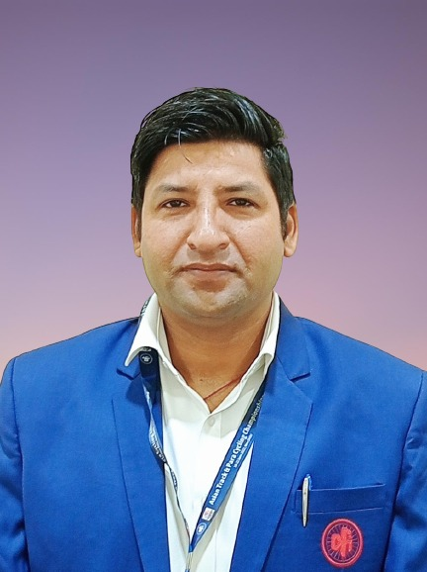

**CURRICULUM VITAE**

**Name: Dr. Vikesh Kumar**

**S/o Sh. Prem Nath**

**Village: Dhammi**

**Post Office: Kandoli Nagrota**

**District: Jammu (J&K)**

**E mail:** [**vikeshsharma888@gmail.com**](mailto:vikeshsharma888@gmail.com)

**…………..................................................................................................**

**CAREER OBJECTIVES**

To secure a responsible position in an esteem organization where my

education can be fully utilized. I believe in hard work as well as in smart

work. It makes my life worth living and to seek position in any sector

that offers professional growth while being resourceful, innovate and

flexible to utilize my skills and gaining respect through my contribution

to the organization*.*

**EDUCATIONAL QUALIFICATION**

* **Matric, K.V Nagrota, Jammu.**
* **Hr Sec. Part II, K.V Nagrota, Jammu.**
* **B. Com, Government SPMR College of Commerce, Jammu.**
* **B.P. Ed, Jammu University.**
* **M.P. Ed, Jammu University.**
* **NET-JRF qualified (Dec 2012, June 2013, Dec. 2013).**
* **JK SET qualified 2013**
* **PhD, Guru Nanak Dev University, Amritsar**

**TECHNICAL QUALIFICATION**

* Basic knowledge in computer.
* FSTO qualified 2013,FTO qualified 2017 in Athletics
* National Commissaire course in cycling 2017.
* Qualified World Anti Doping Alfa level certificate
* Officiating and coaching in athletics.
* Knowledge of SPSS and Zotero

**EXPERIENCE**

* Worked as a Lecturer in the Directorate of Sports and Department of Physical Education University of Jammu during session 2014-2015.
* Worked as Lecturer in the Department of Youth Services and Sports/ Technical Education Jammu and Kashmir Aug. 2016 to Sep. 2018.
* Working as Physical Director in Higher education Department Jammu and Kashmir Sep. 2018 till date.
* Organized state cycling competition 2014 to 2021.
* Organizing Secretary of Jammu and Kashmir state cycling championship 2016, 2017 and 2018.
* Organised three national level competitions i.e. **North Zone Hand Ball Inter-varsity, North Zone Badminton Inter-varsity, All India Handball Inter-varsity (2014).**
* Organised state athletics championship 2016, 2017.
* Technical Official at **Asian Track Cycling Championship 2022**.
* Manager in All India Interuniversity Athletics championship 2018 and Coach in All India Interuniversity Cross country championship 2019.
* Member of Board of Studies, Department of Physical education, 2021 and 2022
* Paper Setter and Evaluator for B.P.ED and B. ED

**PUBLICATIONS**

* **“**Role of Yoga in Stress Management” in International Research Journal of Physical Education and Sports Sciences.” 2014.
* “Comparative Study of Physiological Components of Soccer and Hockey Players of Jammu University.” in I.R.J.P.E.S.S, February 2015.
* “A Comparative Study on Selected Physical Fitness Components Of

Kabaddi and Kho-Kho Players.” in Academic Sports Journal, April 2016.

* “Effect of Circuit Training Program on Selected Motor Abilities among University Male.” in International Journal of Physical Education, Sports and Health, July 2016.
* “Comparative study of physical and physiological profile of basketball and handball players.” in International Journal of Physiology, Nutrition and Physical Education in July 2016.
* “Cardio-Respiratory Fitness and Body Mass Index in Young Male Adults of Hilly and Backward Area.” in International Journal of Science and Research, October 2016.
* “Comparative study of sports achievement motivation between intercollegiate and intervarsity handball players.” in international journal of advanced research and development, November 2016.
* “Relationship between Height, Weight And 1RM to Shot Put Performance in Young Male Adults of Hilly Area” in International Education and Research Journal, December 2016.
* Comparative study of physical fitness parameters of Urban and rural school of Jammu District of Jammu and Kashmir, International Journal of Yogic, Human Movement and Sports Sciences, 2018.
* Anthropometric and body composition differences in sprint and endurance cyclists, International Journal of Yogic, Human Movement and Sports Sciences,2018.
* A comparative study of physical fitness variables of male volleyball players and handball players, International Journal of Physiology, Nutrition and Physical Education, 2018.
* Relationship of anthropometric and physiological parameters with performance among Indian national high jumpers, International Journal of Yogic, Human Movement and Sports Sciences, 2018.
* Body mass index and physical performance of Jammu and Kashmir State school boys. A cross sectional study, physical performance of Jammu and Kashmir State school boys. A cross sectional study International Journal of Physiology, Nutrition and Physical Education, 2019.
* The Application of physics in sports, International Journal of Physiology, Nutrition and Physical Education, 2019.
* Anthropometric Determinants of Sprint Cycling Performance, Studies in Indian Place Names, 2020.
* A social media-based study on the psychological impact of COVID-19 infections in recovered and recovering patients, Journal of Positive School Psychology, 2022.
* Domain-specific differences of physical activity levels among university students: a cross-sectional analysis, journal of critical reviews, 2020.
* Differences of Domain-specific Physical Activity Levels among the Adults of Majha Region of Indian Punjab: A Cross sectional Study, International Journal of Current Research and Review, 2021.
* Anthropometric differences between race walkers and marathon runners: A cross-sectional study. Journal of Fundamental & Comparative Research, 2022.

**CONFERENCES, SEMINARS AND WORKSHOPS**

* Presentation on “7 C’s of a winning champion team” in international seminar on issues and fitness management in October 2015.
* “Comparative Study of Pre-Competitive Anxiety between Individual

Sports and Team Game Players.” in Scientific Culture in Physical

Education and Sports in February 2016.

* Paper presentation on yoga for stress management in National seminar at Desmesh girls college Mukerian, Punjab 2018.
* Delivered Lecturer as Key Resource person on “Sports Day” in K.V Nagrota and K.V Jindrah, 2022 and 2021.
* Delivered Lecturer as Key Resource person on “Health and Wellness” in Webinar conducted By GDC Pouni, 2022.
* One week Workshop on SPSS and R at University of Jammu 2018.
* One week Workshop on writing proposal papers and grants application at University of Jammu 2018.

**PERSONAL TRAIT**

* Ability to adopt new environment quickly. Progressive positive

attitude, punctuality, career minded, Sincerity, honesty, Commitment

towards hard work.

**SPORTS ACHIEVEMENTS**

(a) **Athletics**

(i) **Participated in Senior National.**

(ii) **Participated three times in All India Inter University.**

(iii) **Best Athlete Award two times presented by Jammu University**

**2010 and 2011**

(iv) **Best sports person award presented by SPMR college of commerce 2010.**

(v) 2 Gold Medal, 1Silver, 1 Bronze in KVS Regional level.

(vi) 12 Gold, 3 Silver, and 2 Bronze Medals in Inter Collegiate competition**.**

(vii) 6 Gold medals in inter house competition**.**

**(b) Cycling: Participated four times in Senior National.**

**(c) Hand Ball**

**(i)** Participated in KVS National.

**(ii)** Runner up in KVS Regional level.

**(iii)** Winner and runner up in Inter College Competition.

**(d) Volley Ball:** Inter department (winner).

**(e) Kabaddi:** Winner in Inter House.

**(f) Kho-Kh**o: Winner in inter House.

**(g) Foot ball:** Runner up in Inter house competition.

**Also participated in environment camp and adventure sports.**

**I hereby declare that all the aforesaid information given above is true to the best of my knowledge and belief.**

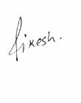

**(Dr. VIKESH KUMAR)**