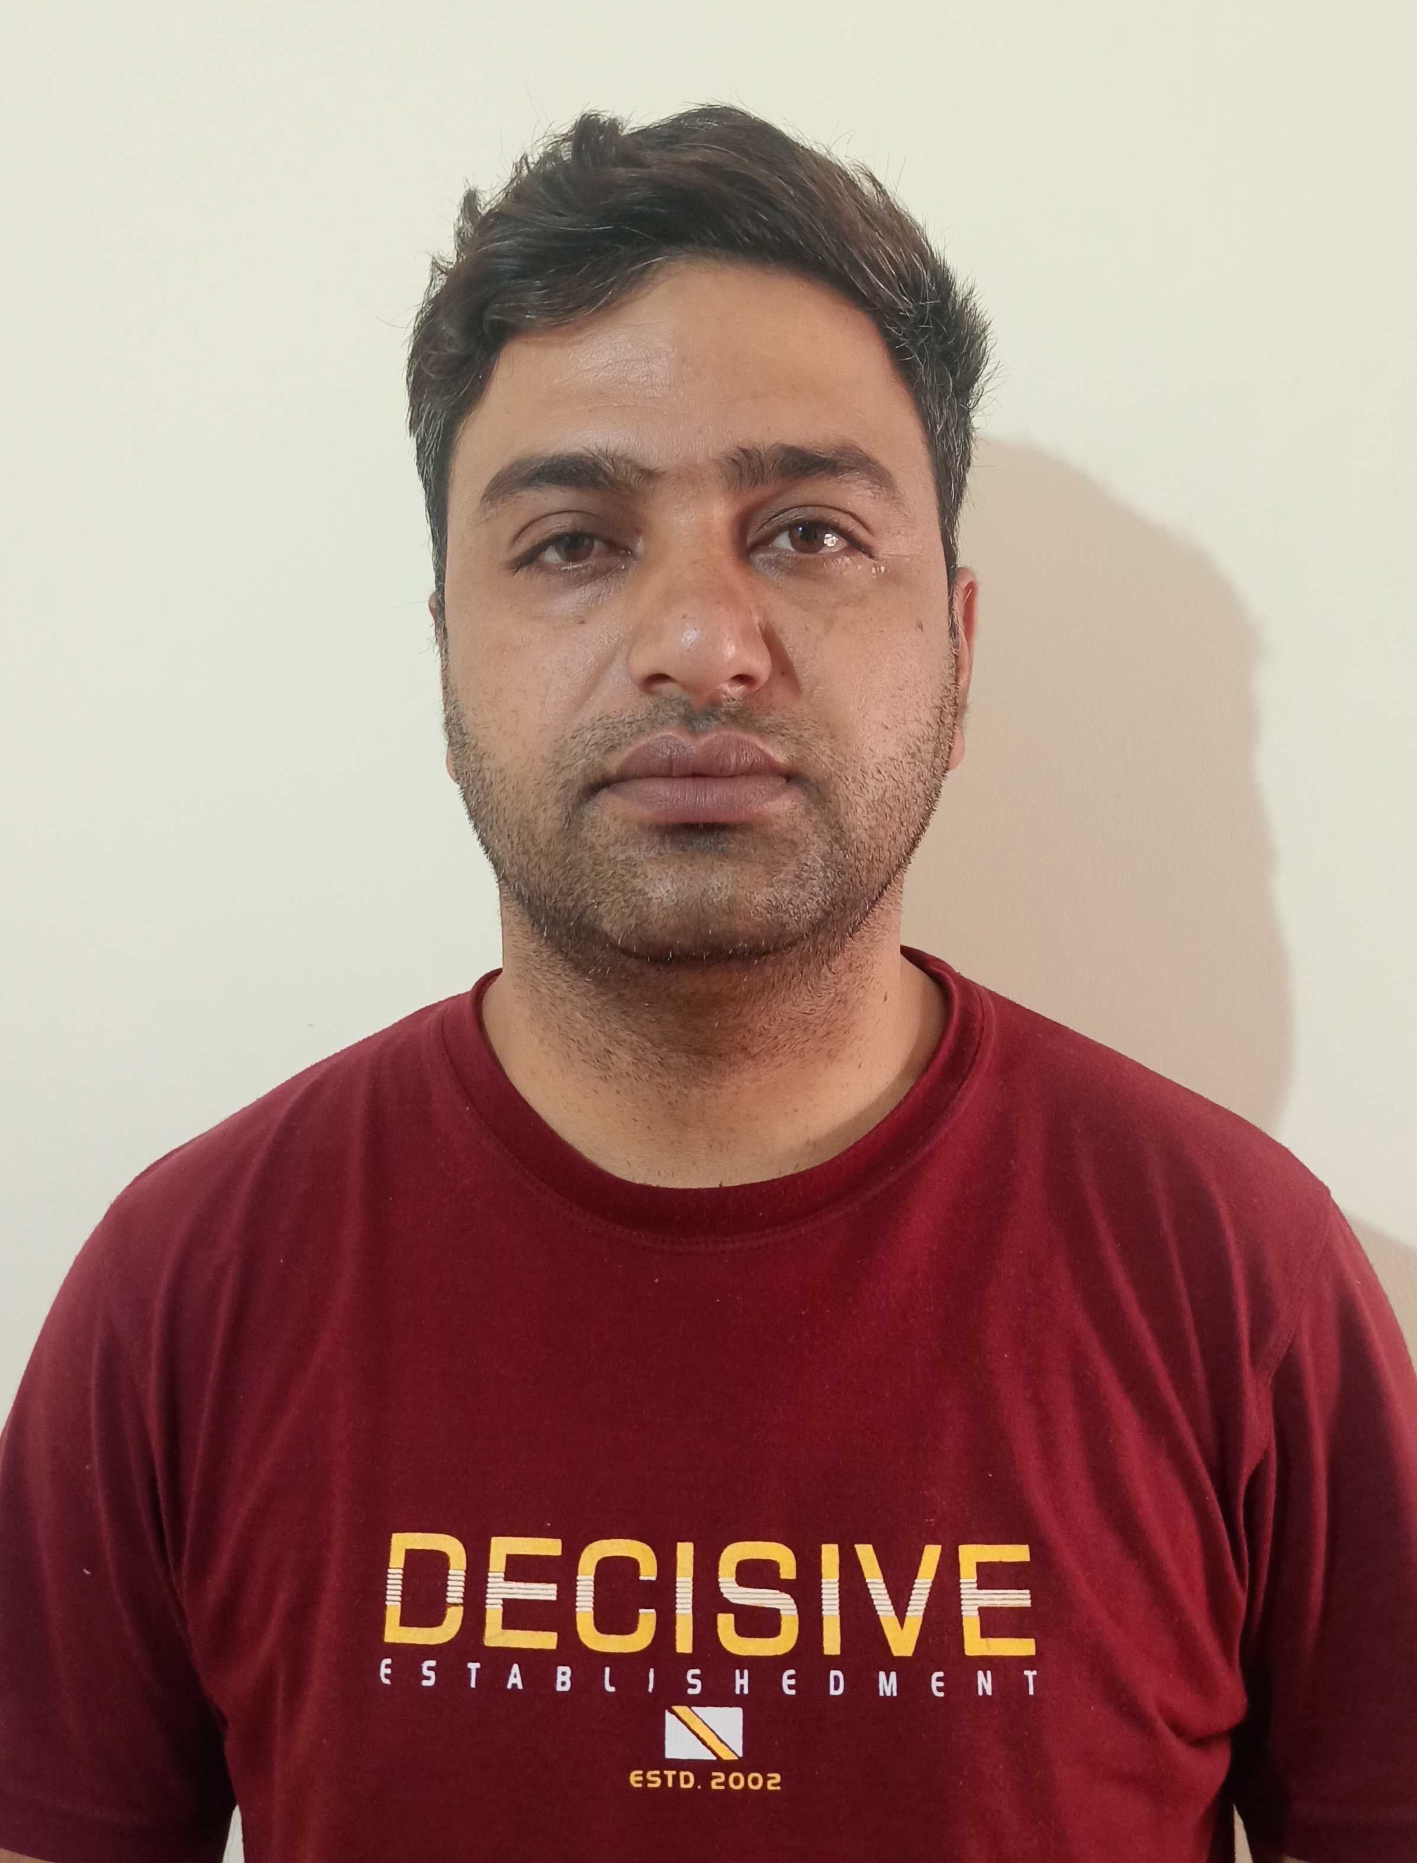**Department of Hindi**

**Name : Chanchal Singh**

**Designation: Lecturer**

**Qualification: M.Phil. in Hindi**

**Email id : chanchal1986singh@gmail.com**

**Area of Specialization: Aadivasi Sahitya**