**RESUME**

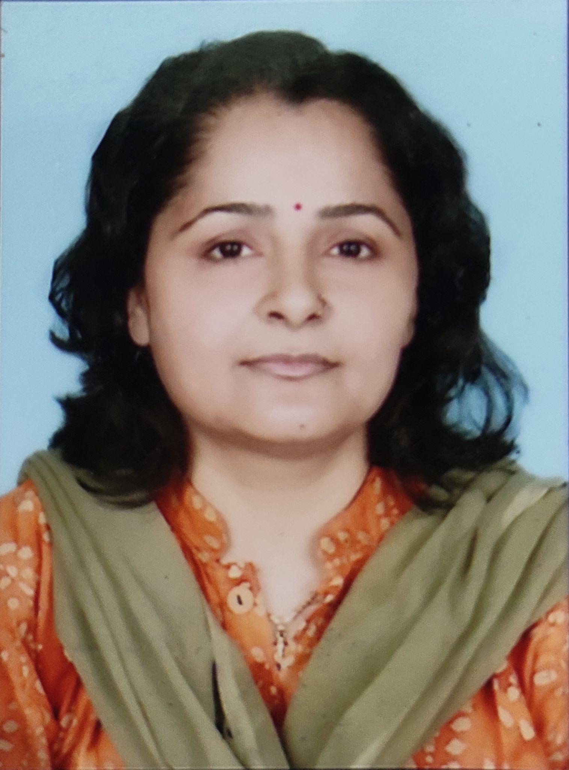

*Name* - Dr. Sarita Khajuria

*(Ph. No.* 9419102163, 7006816343)

*Father's Name* - Sh. Sardari Lai Khajuria

*Husband's Name* - Sh. Devinder Kumar Sharma

*Date of Birth* - 06-10-1973

*Designation* - Assistant Professor

*Qualification* - M.A., Ph.D., NET-JRF (Gold Medalist)

**WORK EXPERIENCE**

* Working as an Assistant Professor of Dogri in the Higher Education Department since

August 2010.(Appointed vide Government order No.: 309-HE of 2010 dated 17-08-2010)

**PUBLICATIONS & APPEARANCES**

* Authored “ATHAROO (A Collection of Dogri Poems)”, Highbrow Publications, 2022.
* Authored “NAVRANG”, Highbrow Publications, 2022.
* Authored “Batour Kavi Mohan Singh”, Highbrow Publications, 2022.
* Wrote the article “Kunwar Viyogi Di Poorane Kavita Sangreh Par Ik Adhyayan”, Sheeraza Dogri, Aug-Sept 2022.
* Wrote the article “Dogri Mahakavya Ik Sarsari Nazar”, Sheeraza Dogri, April-May 2022.
* Wrote the article “Dogri Mahakavya Ch Chitrit Matr Roop”, Sheeraza Dogri, Feb-March 2022.
* Wrote the poem “Manne Di Peed”, Sheeraza Dogri, Aug-Sept 2022.
* Wrote the poem “Khirla Hathyaar”, Sheeraza Dogri, June-July 2022.
* Wrote the poem “Ichcha”, Sheeraza Dogri, Feb-March 2022.

**TRANSLATION WORK**

* A collection of Sham Kshyap's Hindi Poems named Lahu Mein Phansse Shabd was translated into Dogri Rattarde Akhar.
* Translation of Hindi Poem book Geru Se Likha Hua Naam by Sham Kashyap in Dogri by name Laal Mitti Knne Likhe Da Naa.

**Details of Career Enhancement Programmes**

* Six days workshops for preparation of composition in Dogri for non-Cognate organized by NRLC at Cultural Academy Jammu from 15th Feb 2007 to 20th Feb 2007.
* Three days of workshops on multilingual useful glossaries organized by U.T.R.C. Solan from 22.01.2010 to 24.01.2010 at U.T.R.C. Solan.
* Two days workshop on the Development of self-learning material organized by the DDE, the University of Jammu on 20th & 21st Feb. 2016.
* Three days workshop on Feedback on multilingual useful Glossary organized by UTRC Solan from 26.08.2010 to 28.08.2010 at UTRC Solan.
* Three days workshop Feedback on Multilingual useful Glossary organized by Urdu Teaching and Research center from 26.08.2010 to 28.08.2010 at Solan.
* Attended State level Symposium on Biodiversity: Issue and its conversation and presented a poster on March 19, 2012, at G.C.W. Kathua in collaboration with the Indian Science Congress Association.
* Four days workshop Multilingual Useful Glossary organized by U.T.R.C. Solan from 09.06.2012 to 12.06.2012 at Solan.
* Seven days workshop on Preparation Reading Comprehension in Dogri Organized by Northern Regional Language Centre from 21.08.2012 to 27.08.2012 at Jammu in collaboration with Duggar Manch, Jammu.
* Seven days workshop for preparation of the Intensive Course in Dogri organized by N.R.L.C. from 18.07.2011 to 24.07.2011 at Jammu.
* Three days workshop on Smart Technologies held in G.C.W. Parade, Jammu from 16th to 18th Oct. 2012 organized by the B.C.A Department of the College in collaboration with IQAC.
* Five days training course under National Translation Mission Project by CIIL Mysore in collaboration with G.C.W, Udhampur from 11.09.2011 to 15.09.2011 at Udhampur.
* Attended three days women Science Congress at G. C. W. Parade, Jammu from 5th Nov. to 7th Nov. 2013.
* Participated in the Orientation Programme for Translators in Dogri Organised by National Translation Mission, CIIL at Govt College for Women, Gandhi Nagar Jammu from 18th to 25th Aug 2014.
* Participated in the Two-Day workshop on Choice Based Credit system on 22nd & 23rd

April 2015 at Govt college for women, Parade Jammu.

* General Orientation Course from the University of Jammu wef 12th Jan to 10 Feb 2015.
* Participated in a workshop on the Preparation of intermediate courses in Dogri from 30.10.2017 to 04.11.2017 at NRLC Patiala.
* Participated in the Refresher course in MIL from 04.09.2017 to 25.09.2017 from

the University of Jammu.

* Presented Research paper entitled "Digital Hurdles" in translating the Hindi language to Dogri Language in one day National Conference on Recent Advances in science

Literature & Humanities organized by G.D.C. Surankote (Poonch) March 26, 2019.

* Participated in the Refresher Courses in Modern Indian Language from 11.12.2019 to 24.12.2019 from the University of Jammu.
* Participated (as an expert) in the national workshop on Editing and Finalization of Administrative Thinkers by D. Ravindra Prasad, V. S. Prasad, P. Satyanarayana, and Y. Pardhasaradhi in Dogri from 27 June to 05 June 2022, organized by the National Translation Mission, Mysore at Northern Regional Language Centre, Punjabi University Campus, Patiala, Punjab.
* Participated in the workshop titled “Development and finalization of the resource/promotional material in Urdu, Dogri, and Kashmiri for learners under New Delhi Literacy Programme”, organized by Cell for National Centre for Literacy (CNCL), N.C.E.R.T., New Delhi at Hamidi Kashmiri Memorial G.D.C., Eidgah, Srinagar, Kashmir from 26th-30th September 2022.