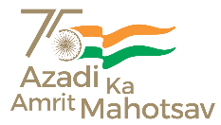

**Office of the Principal,**

Government Degree College, Jindrah.

**Jindrah, District - Jammu, Tehsil – Dansal, J&K - 181224*.***

**Email id**: gdc[jindrah@gmail.com](mailto:jindrah@gmail.com)**Mobile No.** : 9419356459

**Website**: www.gdcjindrah..in

It is information for all the students seeking admission in GDC Jindrah can apply for admission through online portal. The link is given below:-

**Link:** https://jkadmission.samarth.ac.in

For any query

Contact with

Committee members

1. Prof. Paramjit Singh ( Convernor) 7006380773
2. Dr Deepika Member
3. Dr Seema Member
4. Dr Vikesh Member

**Principal**